Financial Lit Name: _______________________

______________ _____________

WS Assessment

Target 7:

Compound interest and investment

**I can:**

* Make computations using compound interest
* Calculate the future value / present value of a periodic deposit investment
* Interpret the graph of the future value function

**Unit 3 Math Topics:**

* Exponential functions
* Exponential base (*e*)
* Exponential growth and decay
* Formulas
* Linear equations and inequalities
* Limits
* Order of operations
* Recursive and iterative thinking: patterns, growth, decline, compound interest

Compound interest is money earned on the money deposited plus previous interest. This is not the case

Interest can be compounded in different ways: Annual compounding, Semiannual, Quarterly, or Daily.

How much interest does $1,000 earn in one day at an interest rate of 6%, compounded daily? What is the balance after a day? Hint: Convert 1 day to year



Marie deposits $1,650 for three years at 3% interest, compounded

daily. What is her ending balance?

Kate deposits $2,350 in an account that earns interest at a rate of

3.1%, compounded monthly. What is her ending balance after fi ve

years? Round to the nearest cent.

Write an algebraic expression for the ending balance after k years

of an account that starts with a balance of $2,000 and earns

interest at a rate of 3.5%, compounded daily.

Create a spreadsheet to find the balance for compound interest as below: Stamp

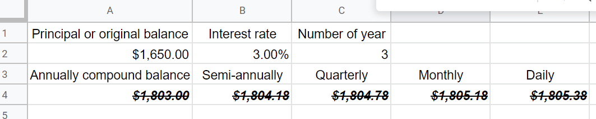

Most banks advertise the **annual percentage yield** (APY) since it is higher than the APR for accounts compounded more than once per year.



Find the APY of the following interest rate, then compare

3.5% annually 3.48% monthly 3.45% daily

Place this in spreadsheet for stamp

Backward

Find the equivalent of 3.5% APY for quarterly, monthly, and daily compound

How much principal must be deposited to earn $1,000 at 5% monthly compound interest in 2 years

How much principal must be deposited in a two-year monthly compound account that pays 3¼ % interest to earn $300 in interest?

Derek has a bank account that pays 4.1% monthly compound. The balance is $910. When will the account grow to $1,000?

How long will it take $10,000 to double at monthly compound 11%?

Kerry invests $5,000 in a monthly compound account for 5 years. What interest rate must the account pay so there is $6,000 at the end of 5 years?

Marcos deposited $500 into a 2.5-year simple monthly compound. He wants to earn $200 interest. What interest rate must the account pay?

Use the daily compound formula to find the missing entries (a 🡪 h) in the table. Round monetary amounts to the nearest cent.

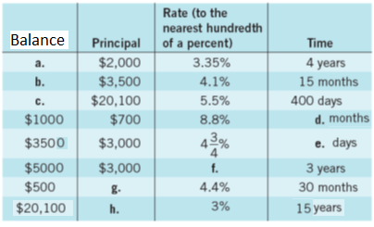

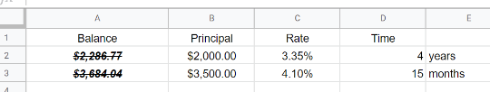Redo this problem using google docs for stamp

(Optional page) Switch gear



What do the three dots at the end of the expression mean? Find the sum above _____________

The idea is, you can add an infinite amount of numbers and get a finite sum!

We say 64 is the **limit** of the infinite sum.

Given the function $f\left(x\right)=\frac{6x-1}{3x+2}$ as the values of x increase to infinity, what happens to the value of f(x)

Set up in desmos to show

We say: the limit of f(x) , as x approaches infinity, is 2

We write: $\lim_{x→∞}{f\left(x\right)=2}$

Find (use desmos) and write the limit of the following; stamps

$g\left(x\right)=\frac{1}{x}$ $h\left(x\right)=1+\frac{1}{x}$

Prove that $\lim_{x→∞}{{\left(1+\frac{1}{x}\right)}^{x}}=e$ Use desmos $\lim_{x→∞}{{\left(1+\frac{r}{x}\right)}^{x}}=e^{r}$

Back to compound interest

Compounding interest daily makes money grow more quickly than simple interest. It is possible to compound interest every hour, every minute, even every second! There are over 31 million seconds in a year. The compound interest formula works with seconds just as it did for compounding daily. There are one million microseconds in one second! It works even better if interest is compounded every microsecond! (continuously)

Say, you deposited $1,000 at 100% interest, compounded continuously, what would your ending balance be after one year?

$B=1000{(1+\frac{1}{n})}^{n*1}$ As n become infinity, we find

$\lim_{n→∞}{1000{\left(1+\frac{1}{n}\right)}^{n}}$ =?

If you deposit $1,000 at 4.3% interest, compounded continuously, what would your ending balance be to the nearest cent after one years? In five years?

 If you deposit $1,000 at 4.3% interest, compounded continuously, what would your ending balance be to the nearest cent after one years? In five years?

Suppose you open an account that pays interest and make no further contributions. This is called the **future value of a single deposit investment**. Many people add money to their savings accounts on a regular basis. The **periodic investments** are the same deposits made at regular intervals, such as yearly, monthly, biweekly, weekly, or even daily.



Rich and Laura are both 45 years old. They open an account at the Rhinebeck Savings Bank with the hope that it will gain enough interest by their retirement at the age of 65. They deposit $5,000 each year

into an account that pays 4.5% interest, compounded annually.

What is the total amount that has been deposited?

What is the account balance of this periodic investments?

How much interest will Rich and Laura earn over the 20-year period?

Linda and Rob open an online savings account that has a 3.6% annual interest rate, compounded monthly. If they deposit $1,200 every month, how much interest they earn over the 10-year period?

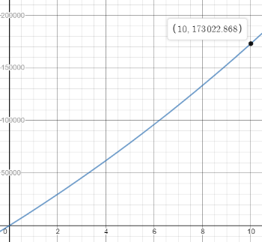Construct a graph of the future value function that represents Linda and Rob’s account for each month. Use the graph to approximate the balance after 5 years. Stamp

Robbie opens an account at a local bank by depositing $100. The account pays 2.4% interest, compounded weekly. He deposits $100 every week for three years.

How much is in the account after three years?

Sketch the graph to show the approximate balance after 5 years? Stamp

Backward

Nick wants to install central air conditioning in his home in 3 years. He estimates the total cost to be $15,000. How much must he deposit monthly into an account that pays 4% interest, compounded

monthly, in order to have enough money? This is called **finding present value of a periodic deposit investment**

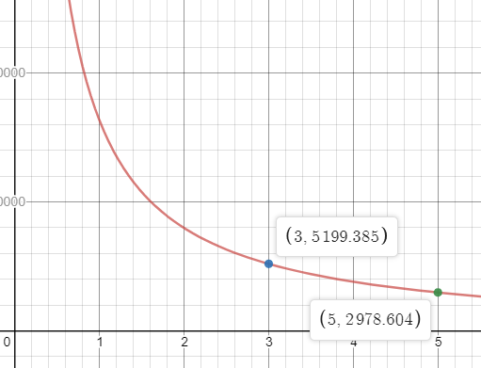Randy wants to have saved a total of $200,000 by some point in the future. He is willing to set up a direct deposit account with a 4.5% APR, compounded monthly, but is unsure of how much to periodically deposit for varying lengths of time.

Find how much he need to deposit in a period of 3 years, 5 years

Graph a present value function to show Randy’s situation. Stamp



Redo in google docs. Stamp

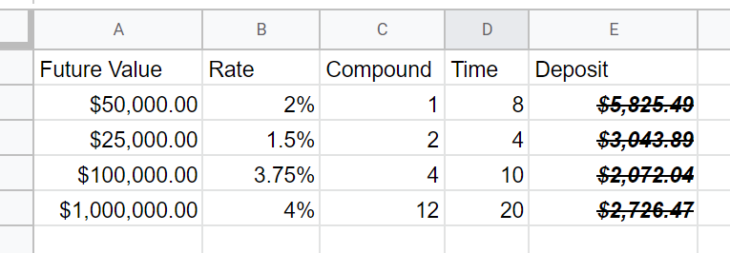

**Assessment Target 7**

**I can…** do compound interest and calculate future / present value of periodic investment

Do this in google docs. Stamp

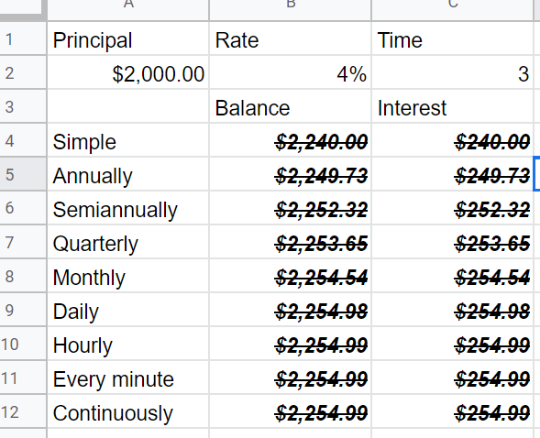A bank representative studies compound interest, so she can better serve customers. She analyzes what happens when $2,000 earns interest several different ways at a rate of 4% for 3 years.

Find the interest if it is

1. computed using simple interest.
2. compounded annually.

c. compounded semiannually.

d. compounded quarterly.

e. compounded monthly.

f. compounded daily.

g. compounded hourly.

h. compounded every minute.

i. compounded continuously.

j.What is the difference in interest between simple interest and interest compounded continuously?

Whitney deposits $9,000 for two years. She compares two different banks. State Bank will pay her 4.1% interest, compounded monthly. Kings Savings will pay her 4.01% interest, compounded

continuously.

a. How much interest does State Bank pay?

b. How much interest does Kings Savings pay?

c. Which bank pays higher interest? How much higher?

d. What other factors might affect Whitney’s choice besides interest?

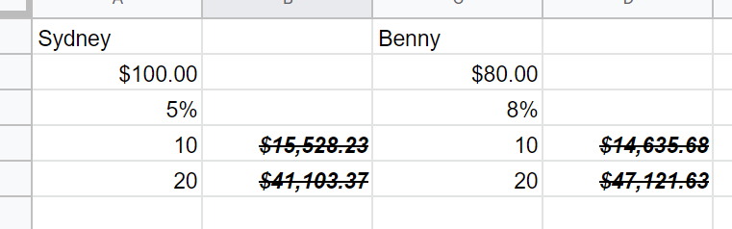Do this in google docs. Stamp

Sydney invests $100 **every month** into an account that pays 5% annual interest, compounded monthly. Benny invests $80 **every month** into an account that pays 8% annual interest rate, compounded monthly. Show your work

a. Determine the amount in Sydney’s account after 10 years, 20 years.

b. Determine the amount in Benny’s account after 10 years, 20 years.

c. Who had more money in the account after 10 years? 20 years?

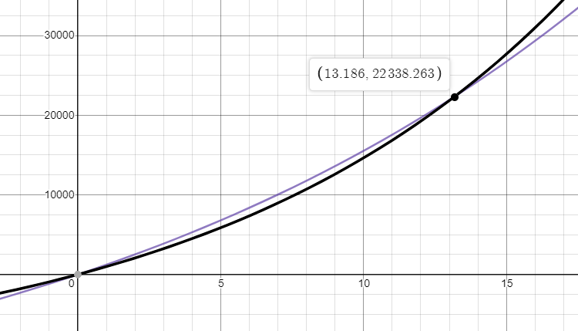Graph Benny and Sydney’s future value function on the same axes.

Stamp Explain what the graph indicates (intersection)

Rich needs $50,000 for a down payment on a home in 5 years. How much must he **single** deposit into an account that pays 6% interest, compounded quarterly, in order to meet his goal?

Marcy wants to have $75,000 saved sometime in the future. How much must she **monthly** deposit into an account that pays 3.1% interest, compounded monthly in 5 years? Use a graphing calculator to graph the present value function. Stamp

